These test papers are copyright and may not be reproduced in any way.
 This paper should be withdrawn after use and stored securely in the school until Friday 19th October 2007.
Test papers may not be used for private tutoring before the above date.

PHYSICS 2007

YEAR 12


TIME ALLOWED FOR THIS PAPER:
Reading time before commencing work: Ten minutes
Working time for paper: Three hours

MATERIAL REQUIRED/RECOMMENDED FOR THIS PAPER

TO BE PROVIDED BY THE SUPERVISOR

This Question/Answer Booklet comprising 39 pages.
Physics: Formulae and Constants Sheet (inside front cover of this Question/Answer Booklet).

TO BE PROVIDED BY THE CANDIDATE

Standard Items: Pens, pencils, eraser or correction fluid, ruler.

Special Items: MATHOMAT and/or Mathaid, compass, protractor, set square and calculators satisfying the conditions set by the Curriculum Council.

IMPORTANT NOTE TO CANDIDATES

No other items may be taken into the examination room.

It is your responsibility to ensure that you do not have any unauthorised notes or other items of a non-personal nature in the examination room. If you have any unauthorised material with you hand it to the supervisor BEFORE reading any further.

STRUCTURE OF THE PAPER

Section | No. of  Questions | No. of questions to  be attempted | No of marks out  of 200 | Proportion of  Examination total
A: Short Answers | 15 | ALL | 60 | 30%
B: Problem Solving | 8 | ALL | 100 | 50%
C: Comprehension and  Interpretation | 2 | ALL | 40 | 20%

INSTRUCTIONS TO CANDIDATES

Write your answers in the spaces provided beneath each question. The value of each question (out of 200)
is shown following each question. You should note that the space made available for an answer is not
necessarily an indication of the length of the answer.

The enclosed Physics: Formulae and Constants Sheet may be removed from the booklet and used as required.

Answers to questions involving calculations should be evaluated and given in decimal form. It is suggested
that you quote all answers to three significant figures with the exception of questions for which estimates
are required. Despite an incorrect final result, you may obtain marks for method and working, provided
these are clearly and legibly set out.

Questions containing specific instructions to show working should be answered with a complete, logical,
clear sequence of reasoning showing how the final answer was arrived at. Correct answers which do not
show working will not be awarded full marks.

Questions containing the instruction "Estimate" may give insufficient numerical data for their solution.
Students should provide appropriate figures to enable an approximate solution to be obtained.

When descriptive answers are required, you should display your understanding of the context of a question.
An answer which does not display an understanding of Physics principles will not attract marks.

Section A: Short Answers
Marks allocated: 60 marks out of a total of 200 (30%)

Attempt ALL 15 questions in this section. Each question is worth 4 marks.

Answers are to be written in the space below or next to each question.

1. Sonar devices are used by sailors to locate the position of the ocean floor by using echoes.

(a) Explain the physics principle involved in measuring the depth of the ocean floor.

(b) When using the echo sounders the pulse returns in a time of 85 ms.
How deep is the ocean at this location?

2. Neptune has a mass of about 17 times that of Earth and has a radius of 24 700 km.
Calculate the magnitude of the gravitational field at the surface of Neptune.

3. Consider the two identical vases A and B which are placed on a table as shown.
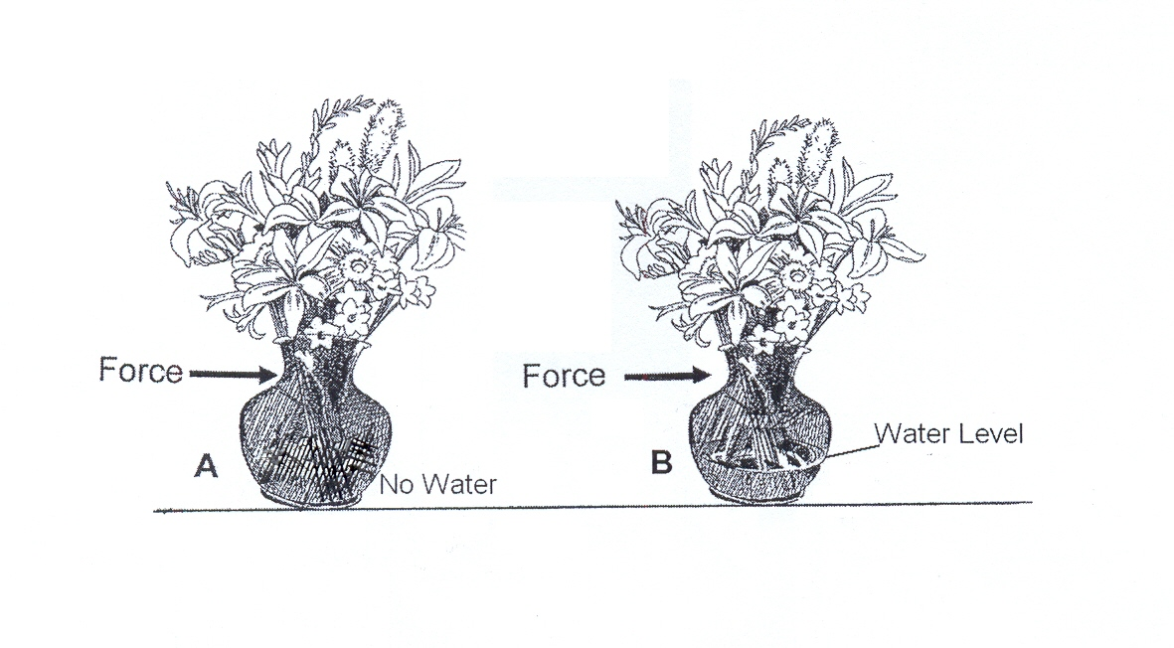

The same force is applied to both vases as shown in the diagram above. The force is applied
until both vases reach an angle where they become unstable and tip over without the force being
applied. Which vase would have the greatest base-table angle before it tipped over?
Explain the physics principles involved.

4. A trumpet is being played close to a wall of 4 m² in area. During a 3 min playing time
400 mJ of energy falls on the wall.

(a) What is the average sound intensity to fall on the wall?

(b) Determine the sound intensity level at this point.

5. At a recent “Red Bull” air spectacular in Perth aeroplanes performed spectacular aerobatics.

(a) Calculate the maximum ‘g force’ on a pilot attempting a “loop the loop” of radius 60 m
in a vertical plane.
The pilot’s mass was 75 kg and the speed was a constant 108 km hr ^{– 1}.

(b) Where in the “loop the loop” was the plane and pilot to experience this maximum force?

6. A student rolls a marble across a horizontal table and then the marble falls on to the floor.
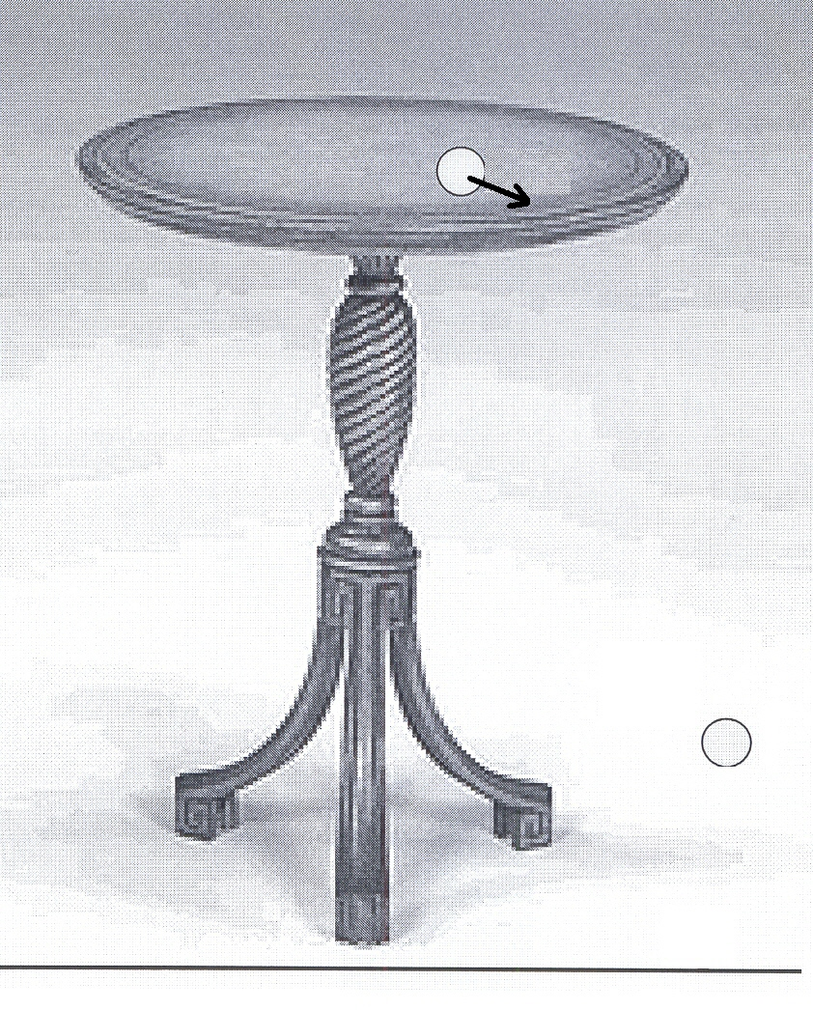

(a) What is the time interval between the marble leaving the 80cm high table at 5 m s ^{– 1}
and landing on the floor?

(b) What is the horizontal displacement of the marble the instant it hits the ground?

7. Electric power is transmitted from Collie power station to Armadale at a very high voltage.

(a) Give reasons for Western Power’s decision.

(b) Why, in transmitting the power from the Armadale substation to local residential areas, is the
high voltage reduced?

8. Two loudspeakers are separated and connected so that they produce sound of identical frequency
of 500 Hz and are in phase.
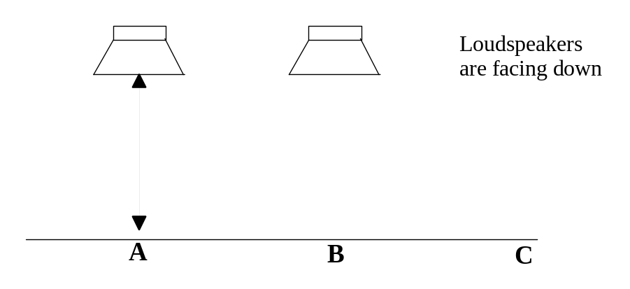
An observer walks along the line A - C which is parallel to both speakers. When at B the observer
notices that the sound heard from the speakers becomes quieter. Explain why this occurs.
You may draw on the diagram above to assist your explanation if you wish.

9. A recent change in car design in the light of the petrol crisis is the hybrid car. It combines electric
and conventional motors. An innovative way of slowing the car down is to allow the metal wheel
hub to spin between the poles of a magnet.
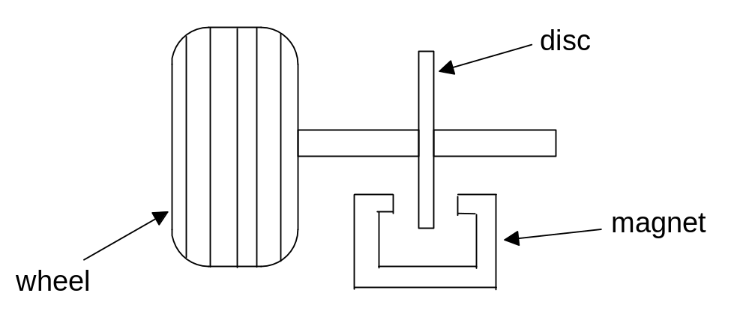

(a) Explain, using your knowledge of electromagnetism, why the wheel would slow down.

(b) Explain what has happened to the Kinetic Energy of the car as it brakes.

10. Following a laboratory investigation on the effect of an external magnetic field on a current carrying
conductor, a student set up the apparatus shown in the diagram below to report her findings to the rest
of the Physics class.

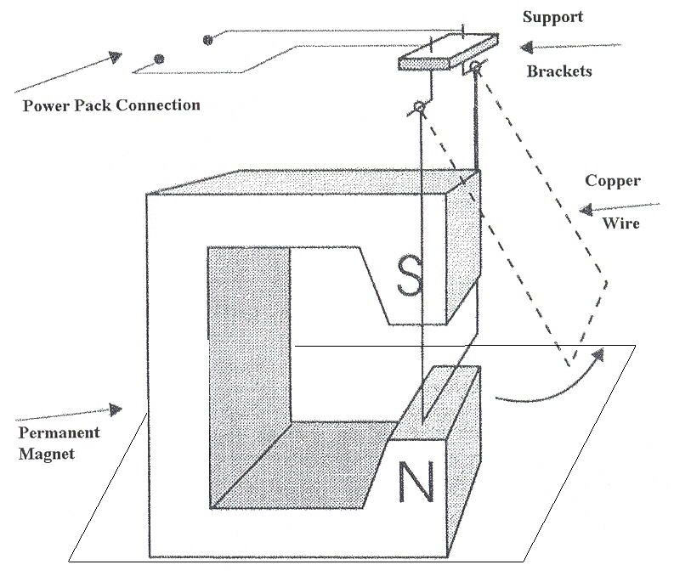

(a) When connected to a power pack, the copper wire loop swings outwards as shown on the diagram.
Label the terminals on the power pack +ve & -ve so as this will occur.

(b) If you were a student and demonstrated the wire swinging outwards when the power pack was connected,
what explanation would you give as to why this happened?

11. The moving coil ammeter used by a student to measure the current in an experimental circuit
in the laboratory works on the principle of the electric motor. Rotation is restricted by a steel
spring. (not shown in the diagram)
The coil has the following characteristics:

Shape of coil: Rectangular, 20.0 mm wide, 40.0 mm long
Number of turns in the coil: 75
Magnetic field strength acting on the coil: 0.080 T
Maximum current through the coil: 50 mA
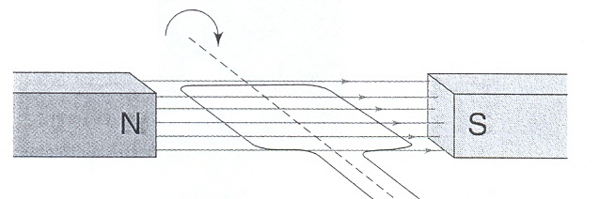

Calculate the maximum torque on the coil that the coil is designed to receive.

12. An electron and a proton both enter a uniform magnetic field as shown in the diagram below.
The speed of both is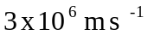and the field strength is 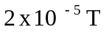.
The field is directed into the paper.
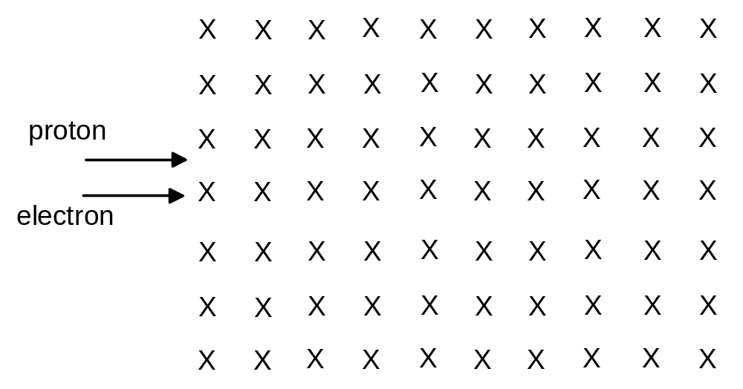

(a) On the diagram draw the path of an electron in the magnetic field. Label it A.

(b) Calculate the radius of A.

(c) Draw the approximate path of a proton and label it B. No calculation is required.

13. (a) ESTIMATE the energy of an X ray photon

(b) How many photons would you receive during an X ray examination if the X ray
tube, rated at 2 mW, was activated for 2 secs?

14. When sodium chloride (common salt) is placed in a flame, the flame glows bright yellow.
The diagram shows some of the energy levels of a sodium atom.

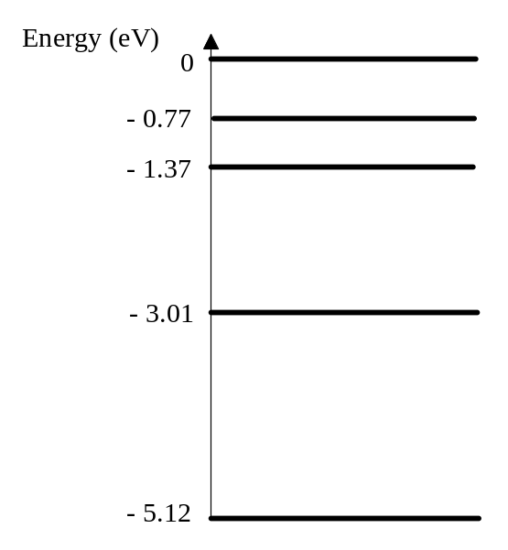
(a) On the diagram label:
(i) the ground state of the atom,
(ii) the first excited state.

(b) If yellow light has a frequency in the range 500 x 10 ¹² Hz to 540 x 10 ¹² Hz then
select a transition that could result in yellow light and support your answer with a
suitable calculation.

15. A body of weight W is held in position by two light strings under tension T₁ and T₂ .

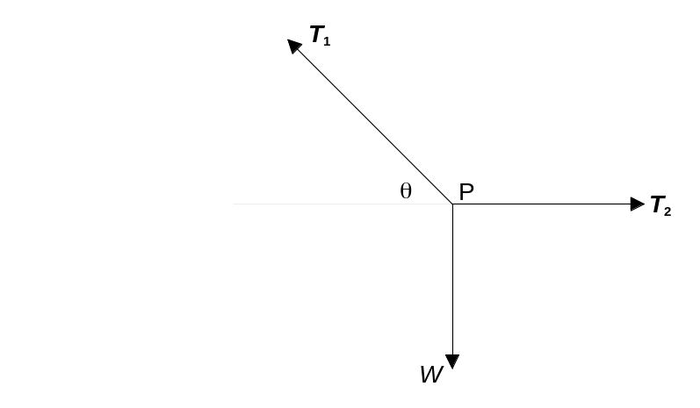

Which of the following equations about the forces which act at point P are correct?

(a) 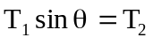
Answer here

(b) 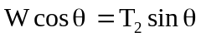

(c) 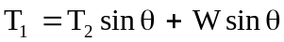

(d) 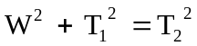

Briefly explain your choice.

END OF SECTION A

Section B
Marks allotted: 100 marks out of a total of 200 (50%).

This section contains 8 questions.

You should answer: ALL of the questions.

Answer the questions in the spaces provided

1. (13 marks)
A sign outside a shop near a soccer stadium is suspended from a beam ABC, which is uniform,
and is 4. 0 m long with a mass of 40.0 kg. The beam is suspended by two identical wires
attached at A and B. The tensions in the two wires are 170.0 N and 250 N respectively
(see the diagram below). The wires have a radius of 8.00 x 10⁻³ m which corresponds to a
cross sectional area of 2 x 10 ^{– 4} m ² and are 2.0 m long.
The graph shows the stress strain graph of the metal from which the metal wires are made.

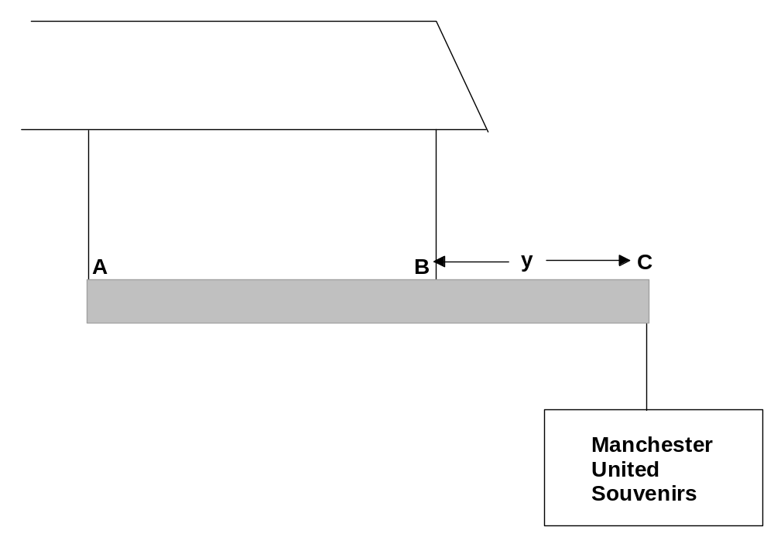

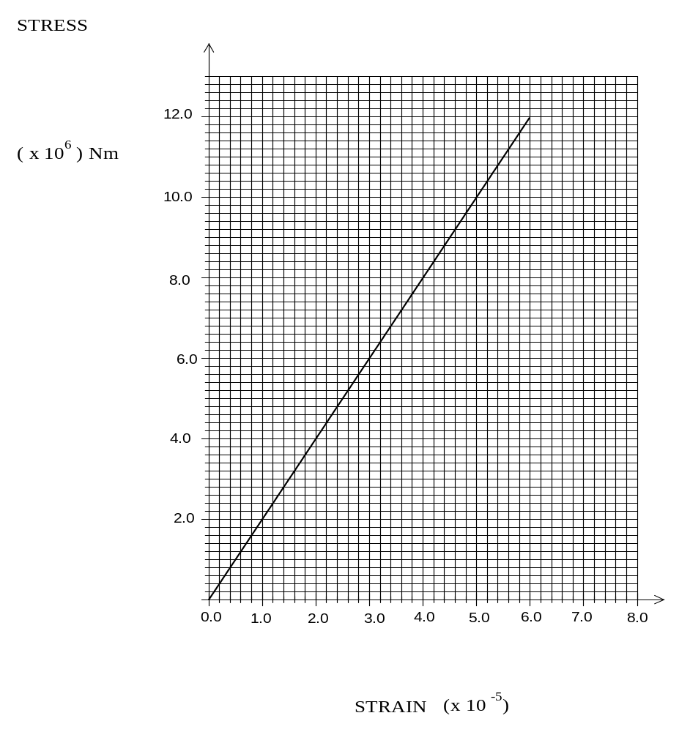

(a) What is the weight of the sign ‘Manchester United Souvenirs”? (3 marks)

(b) What is the distance ‘y’? (4 marks)

(c) What is Young’s Modulus for the metal used to make the supporting wires? (2 marks)

(d) What is the stress in wire A? (2 marks)

(e) What does the area under the stress – strain graph represent? (2 marks)

2. (13 Marks)
A young golfer Michael Woods is trying to follow in his fathers footsteps and is practising
his golf. He has a wedge, a club designed to hit the ball high and have little roll after it bounces,
and is hoping to clear a tree that is directly in his path to the green
The club is designed to hit the ball at an angle of 40⁰ to the horizontal and Michael, even
though young, can hit the ball so that it leaves the golf club with a speed of 32 m s⁻¹

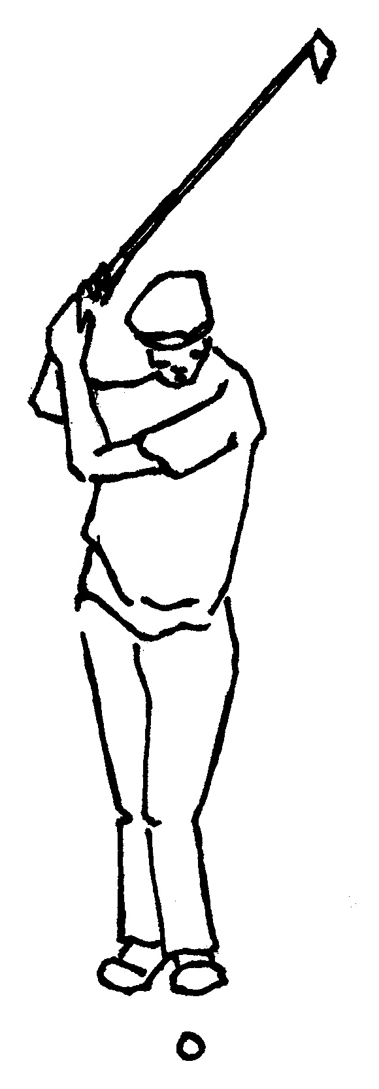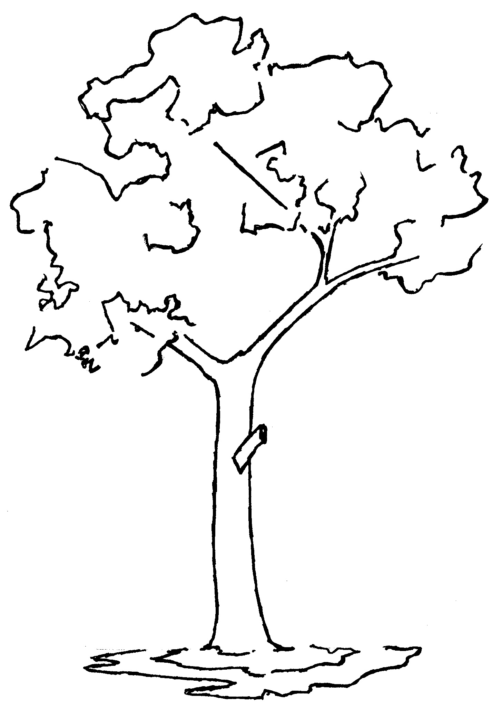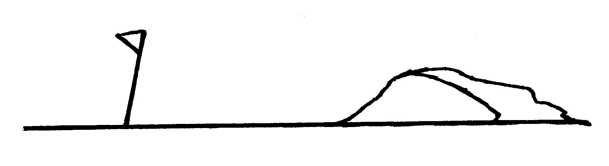

(a) What is the horizontal component of the golf ball’s velocity? (2 marks)

(b) What is the vertical component of the golf ball’s velocity? (2 marks)

(c) How long will the golf ball be in the air? (assuming it clears the tree ) (3 marks)

(d) If the ball clears the tree and lands on the front edge of the green calculate the distance
from Michael to the green. (2 marks)

(e) Show, by calculation, that if the tree is 19m high and is 40m away from Michael, that
the ball will clear the tree. (4 marks)

3. (13 marks)
Sound waves are produced by a loudspeaker and reflected at the water’s surface to produce
a standing wave. A displacement antinode is located at the top of the container.
In an experiment to measure the speed of sound in CO₂ a student uses this apparatus and
changes the length of the CO₂ column by varying the water level. He adjusts the frequency
of the loudspeaker for each length of CO₂ column until he hears the gas in the column resonate.
He records this frequency and the associated length.
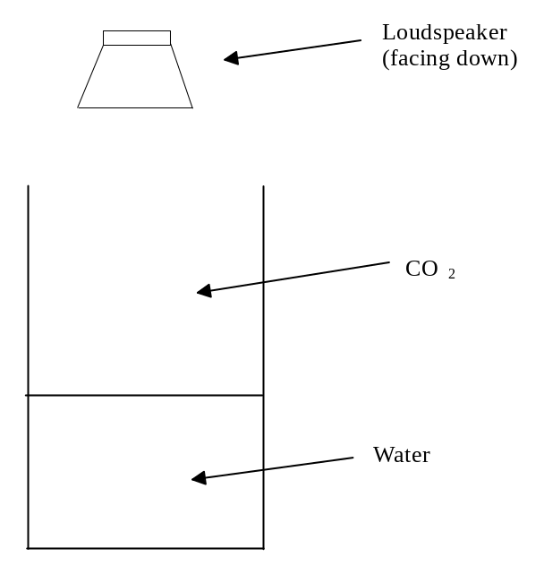

(a) What do you understand by the term “to resonate”? (2 marks)

(b) How does he detect that the gas in the column is indeed resonating? (2 marks)

(c) Draw the displacement standing wave pattern for the fundamental. (2 marks)

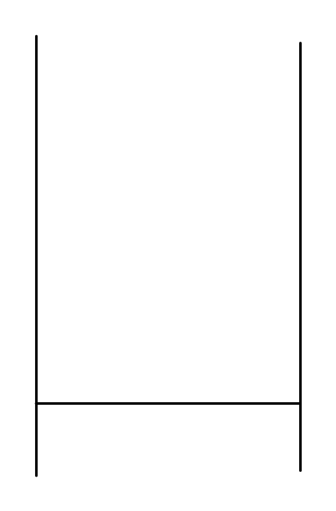

(d) The student obtained the following resonance data displayed in the table below.
EITHER
Choose suitable axes and plot a graph to determine a value of the speed of sound in CO₂.
OR
If you use your graphics calculator then note the axes used, any measurements you
made and how you used this information in your calculation. (5 marks)

Frequency (Hz) | Resonance length of tube(mm)
513 | 140
408 | 190
307 | 250
263 | 300
235 | 350
200 | 400
187 | 450



Graphics calculator: used / not used

(e) Explain why the graph did not pass through the point (0, 0). (2 marks)
4. (11 marks)
The diagram below shows some of the energy levels of the outermost electrons in the Cesium atom.
E₁ represents the ground state.
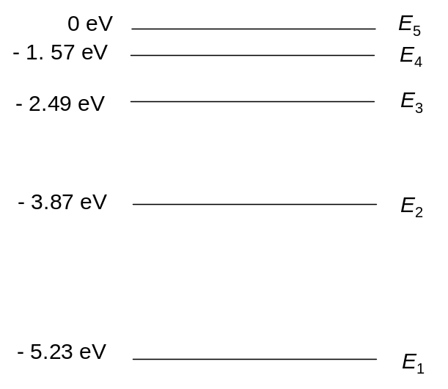

(a) After an electron has been excited to the E₃ level it, after a short time, returns to the ground state.
On the diagram, show possible downward transition(s) of this electron. (3 marks)

(b) Calculate the highest photon frequency emitted in the transitions in (a). (3 marks)

(c) In which part of the electromagnetic spectrum will the line in (b) appear? (1 mark)

(d) Explain how a line emission spectrum is produced and what information can be obtained
from the energy levels. (4 marks)

5. (14 marks)
A 0.15 kg wire in the shape of a closed rectangle 1.5 m wide and 2.5m long has a total resistance
of 0.75 Ohms. The rectangle is allowed to fall through a uniform magnetic field directed
perpendicular to the direction of motion of the wire. The rectangle accelerates until it reaches a
constant speed of 2 m s ⁻ ¹, with the top of the rectangle still not within the field.
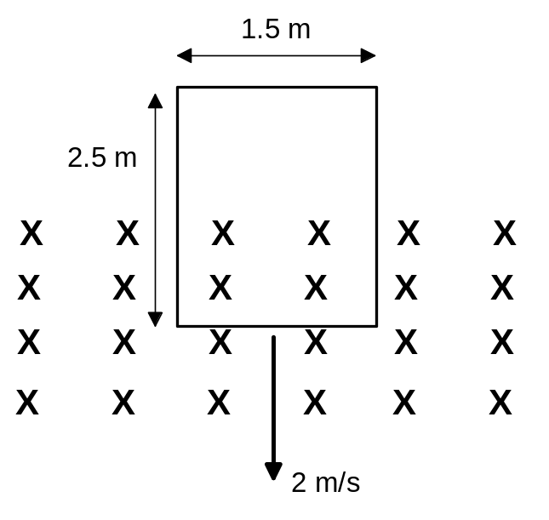

(a) Calculate the magnitude of the field B. (5 marks)

(b) Using physics principles, explain why the rectangular wire reaches a maximum speed.
(2 marks)

(c) What will be the induced current when the rectangle is completely in the magnetic field?
Give an explanation. (2 marks)

(d) The rectangle is replaced by a coil of measurements 0.2 m x 0.2 m.
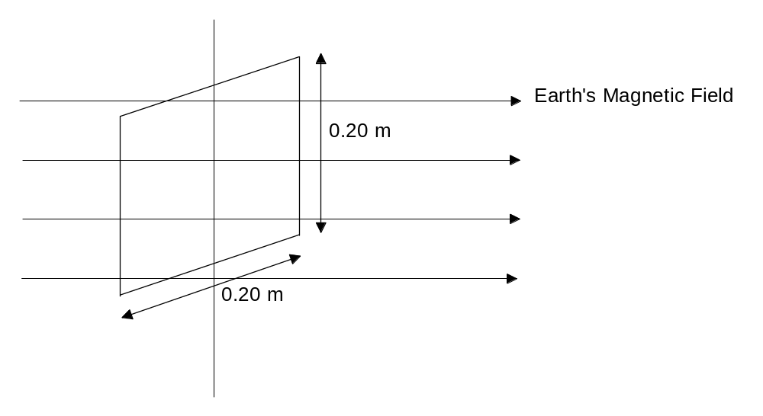

This coil consists of 100 turns of wire and rotates about a vertical axis at 1500 rpm, as indicated
in the above diagram. The horizontal component of the earth’s magnetic field at this location
is 2 x10⁻⁵ T. Calculate the maximum voltage induced in the coil by the earth’s field. (5 marks)

6. (12 marks)
Below is a picture of two people playing “totem tennis”. They hit the ball horizontally and the ball is
attached by a strong cord of length 2.5m to the top of the pole. In the game the ball of mass 0.4 k is
travelling horizontally and the angle it makes with the post is 60⁰ .

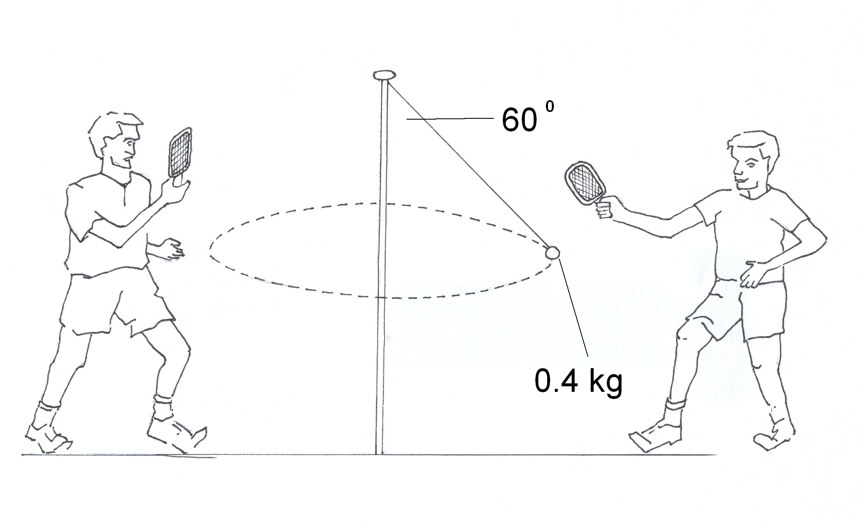

(a) On the diagram show all the forces acting on the ball. (2 marks)

(b) Find the tension in the rope. (3 marks)

(c) Show that the speed of the ball is about 6 m s ⁻ ¹. (4 marks)

(d) With out performing calculations predict how the speed would need to change if the angle,
as shown, decreased to 45 ^{0.}. Explain your reasoning. (3 marks)

7. (13 marks)
A remote farm in the South West of Australia is situated 40 km from the nearest Western Power
110 kV power lines. There are two houses on the farm very close to each other and both are
connected to the electric power grid as shown in the diagram. The electric circuit in both houses
is designed for 240 V AC.
The wires from the transformer to the houses have a resistance of 2.0 mΩ m⁻¹.
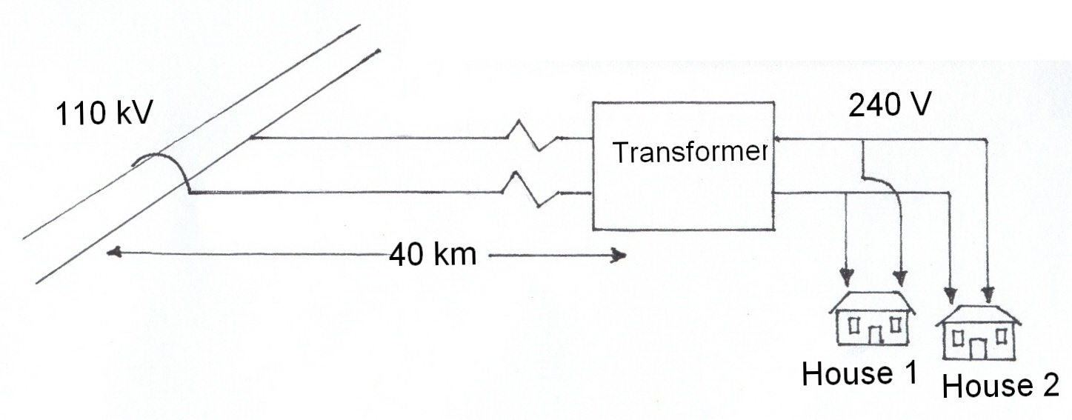
(a) Explain the role of the transformer in the above diagram and calculate the “turns ratio”.
(3 marks)

(b) Explain why the transformer is placed at the end of the 40 km line rather than at the beginning.
(3 marks)

(c) The farmer turns on the electric kettle, nominally rated at 2 kW at House 1 which is 100m
from the transformer. The kettle’s heating element has a resistance of 30 Ω.
What is the power actually delivered to the kettle? (4 marks)

(d) A similar kettle is turned on at the same time in House 2. How would your answer to the
previous question change? Give a reason but no calculations are required. (3 marks)

8. (11 marks)
Two identical thin pavers of length 60 cm and mass 3 kg are placed over the edge of a frictionless
surface, as shown in the diagram below.
What is the maximum overhang such that neither thin paver falls over the edge?
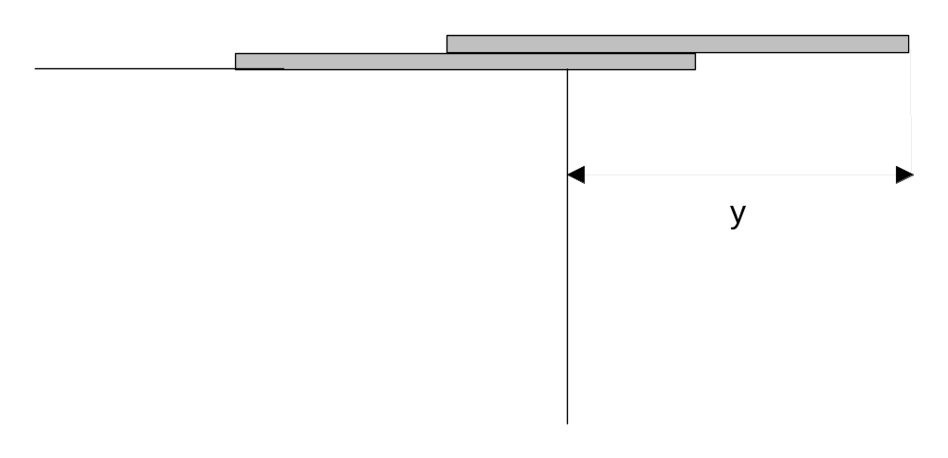

(a) Find the distance y. (3 marks)

Now the situation is changed and one of the pavers is lifted, as shown below.
The supporting cable is connected to the end of the paver.

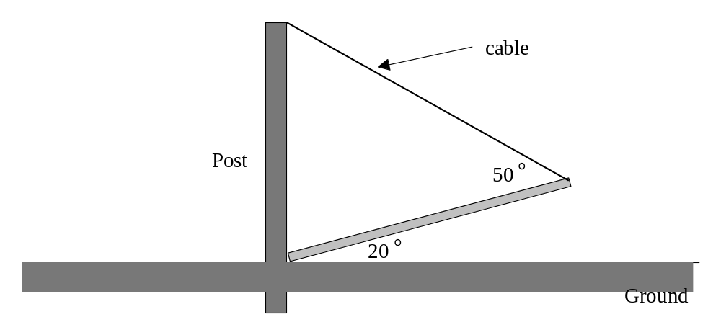

(b) Find the tension in the cable. (4 marks)

(c) The same paver is used as a bridge across a gap between two smooth tables.
Indicate on the diagram all the forces on the paver and indicate the parts of the paver
that are under compression and tension. (4 marks)

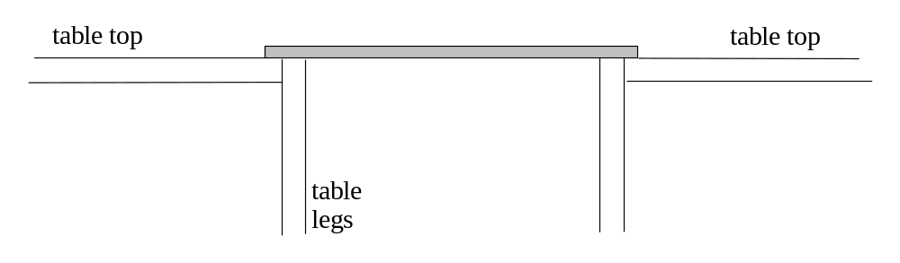

END OF SECTION B

Section C: Comprehension and Interpretation

Marks allotted: 40 marks out of 200 (20%)

SECTION C: Comprehension & Interpretation
Marks allotted: 40 marks out of 200 marks total (20%)
BOTH questions should be attempted.

Read both passages carefully and answer all of the questions at the end of each passage. Candidates are reminded of the need for correct English and clear and concise presentation of answers. Diagrams (sketches), equations and/or numerical results should be included where appropriate.

Question 1 (20 marks) Active Noise Control.

Para 1
Professor Graham Smith became aware how noisy his fan on his computer was when working late one evening. He turned his computer off and then appreciated how much quieter his office was. As a scientist working in a university he decided to do something about it. He developed an anti noise system suitable for computers but it also, he predicts, will have other uses.

Para 2
The system is likely to become popular in the future as microprocessors in computers grow bigger and more powerful and therefore need bigger fans to keep them cool. As the fan rotates it generates frequencies that depend on the size and speed of rotation of the blades on the fan. As the fan rotates more quickly the noise becomes both louder and of a higher frequency. Graham’s system uses a technique called active noise control. (ANC)
The idea is to measure the unwanted noise with a microphone and then reproduce it faithfully 180° out of phase with the original signal. When the signals merge the sound heard becomes considerably reduced.

Para 3
His team achieved a noise reduction of 20dB by having four microphones around the corners of the fan. These microphones were connected to four speakers which generate the appropriate anti – noise. Graham estimates that the total cost, if mass produced, will be about $20 but concedes that for this to happen many other applications of the ANC system must be found.

QUESTIONS:

1. Why, in the future, will bigger fans be needed? (2 marks)

2 Why, as the fan rotates more quickly, will both the frequency and the noise level increase?
(3 marks)

3. Draw the signal both before and after it passes through the Active Noise Control (ANC) (3 marks)
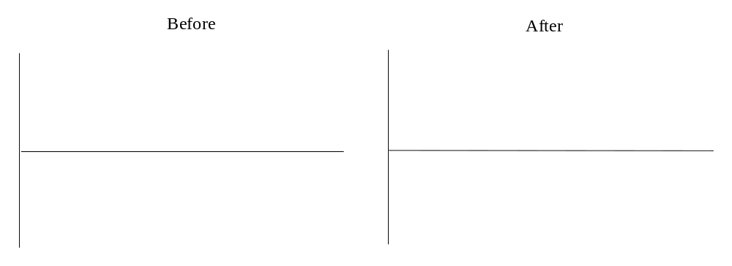 Be sure to label your axes

4 Now, using the axes below, show the signal after merging and exiting from the Active
Noise Control.
Again label your axes. (2 marks)]
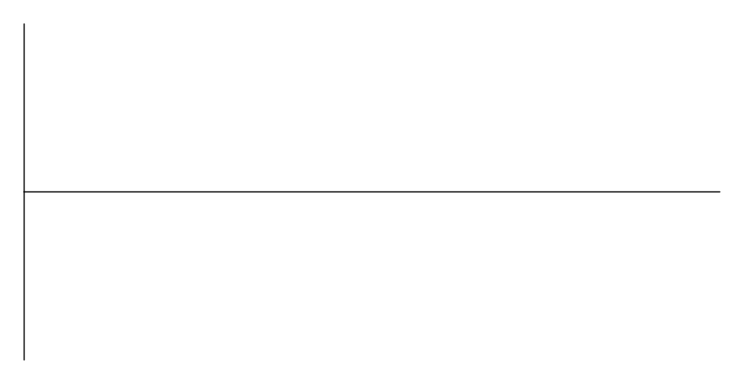

5. Explain why the noise level is reduced as a consequence of passing through the Active
Noise Control. (2 marks)

6 If the original noise level was 10⁻⁸ W m² , then what will be the noise level after passing through the Active Noise Control? (3 marks)

7. Why do they have 4 microphones and 4 loudspeakers rather than just one of each?
(2 marks)

8. Is the term anti – noise a fair description? (1 mark)

9. What other applications could this device have? Give reasons. (2 marks)

Question 2 (20 marks) Transit of Venus

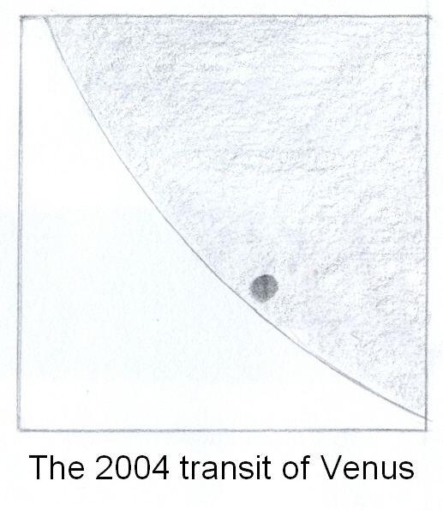
Para 1
Nearly four centuries ago a young astronomer by the name of Jeremiah Horrocks made history by predicting and observing the transit of Venus. A transit is when a planet passes between the Earth and the Sun appearing as a dark spot moving across the Sun’s surface. Only Mercury and Venus are between the Earth and the Sun. The last time Venus transited the Sun was June 8th 2004 and the next time will be 5th June 2012. It takes about 30 mins for the complete transit. The orbital planes of Venus and the Earth around the sun are not identical and this affects the times between transits. No one alive had ever seen a transit before the June 8th 2004 observation yet the next will be in 2012 on the 6th June at 10.09 pm in Perth.

Para 2
The fact Horrocks could predict its transit with accuracy and also calculate the earth- sun distance is a testimony to the precision he took his measurements with. The distance from the earth to the sun is known as one astronomical unit [AU].

Para 3
The path of Venus across the sun depends on where the viewing takes place. It is different at the equator as compared to what you would view in Perth. By combining observations at different latitudes and knowing the radius of the earth it is possible to deduce the solar parallax angle θ and hence deduce the earth sun distance.
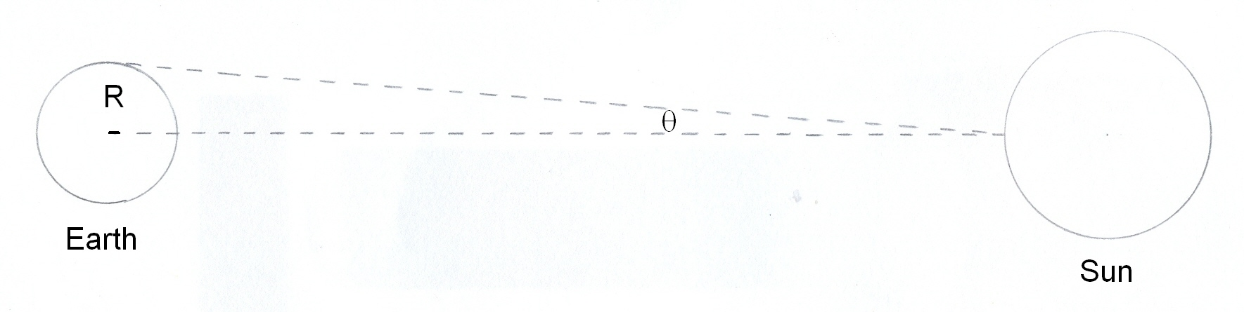

Para 4
It is recommended that you observe the sun at least a day or so before the transit time in case there are sunspots. Sunspots are areas on the sun’s surface that have a darker colour than the surrounding area. Remember never look at the sun directly either with your eye or through a telescope. Use a telescope or a pair of binoculars to project the image onto a piece of card.

Questions

1. Which other planets can have a transit path when viewed from earth? Explain your choice. (2 marks)

2. Draw a picture to show the transit of Venus using the diagram below. (3 marks)
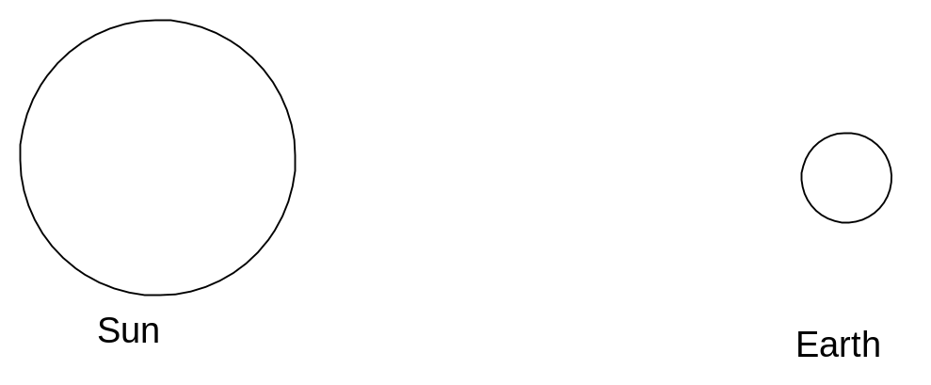

3. What does the expression “the orbital planes are not identical” mean? Use this idea to explain why the Venus transit is an irregular event. (3 marks)

4. Using your data sheet calculate the earth – moon distance in AU. (2 marks)

5. Calculate the time, in seconds, for Venus to orbit the sun if the Sun – Venus distance
is 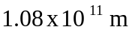. (3 marks)

6. If the solar parallax angle was 2.5 x 10⁻³ degrees then calculate the earth – sun distance. (3 marks)

7. Why, if you want accurate results, would you choose two locations on earth separated by as
large a distance as possible? (2 marks)

8. Why are you advised to view the sunspots before the transit observation and why should you
never view the sun directly? (2 marks)

END OF EXAMINATION

